WEEK PRACTICAL – 01
1.id: 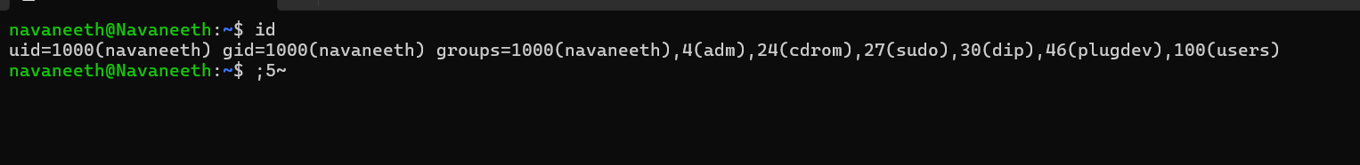
Report: After running the id command, I could see my user details. It showed my username as Navaneeth, along with the user ID, group ID, and the groups I belong to like sudo and plugdev.
2.env:
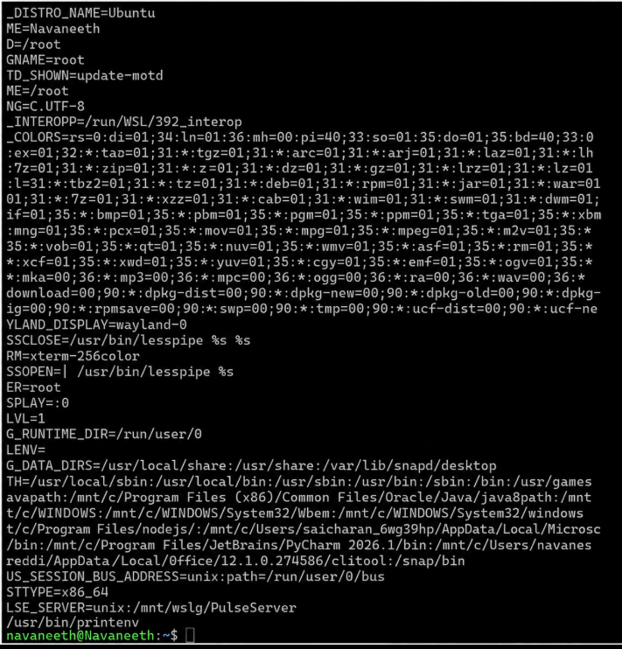
Report: When I executed the env command, many environment variables were displayed. I observed variables like HOME=/home/navaneeth, USER=navaneeth, PWD=/home/navaneeth/OSSP, and PATH, which contain information about the system environment.
3.Export:
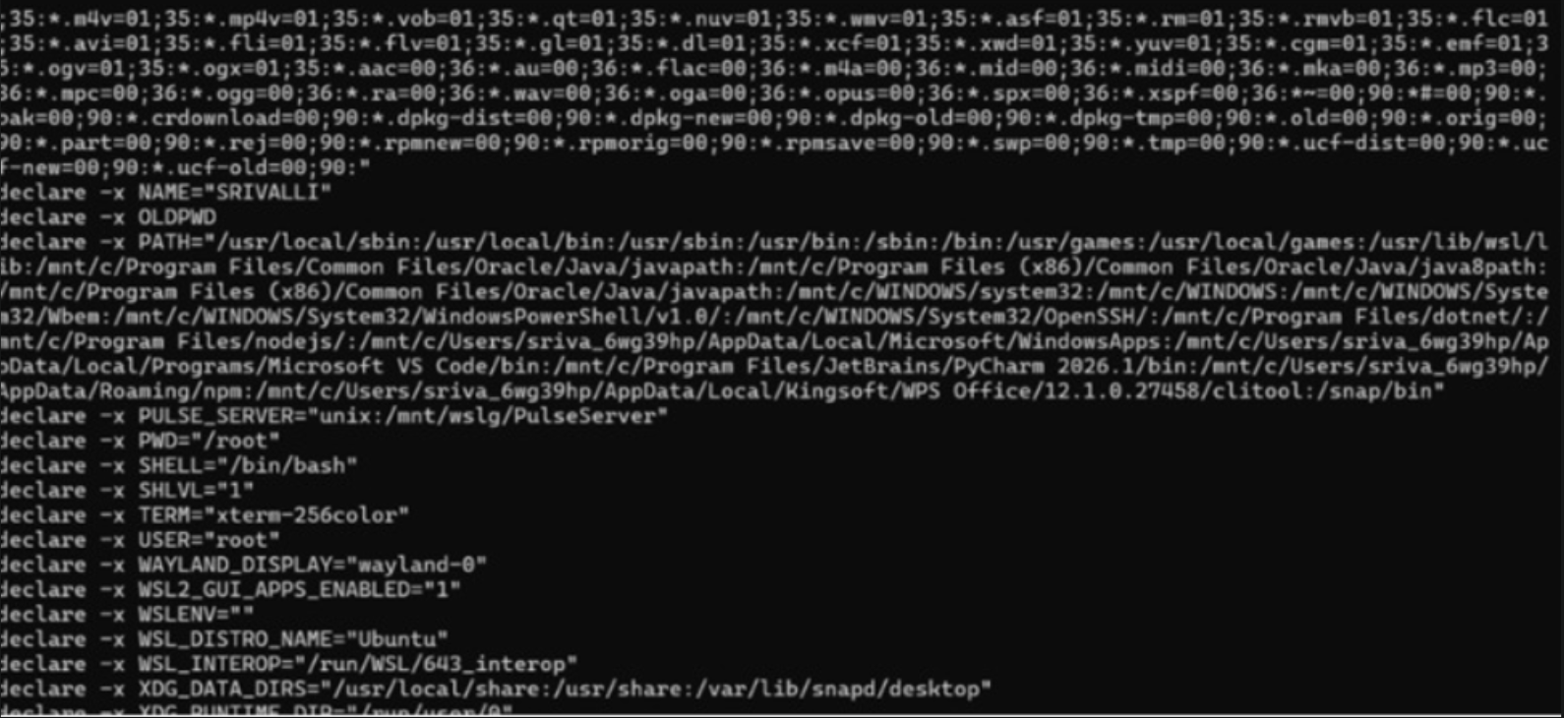Report: The export command displayed the exported environment variables. I observed that variables such as HOME, USER, PWD, PATH, and other system variables were available and exported for the current session
4.Alias:
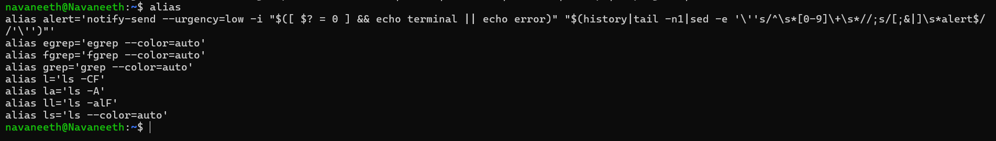
Report: After executing the alias command, the terminal displayed a list of shortcut commands. I observed aliases like grep, ls, and ll, which are used as shortcuts for commonly used commands.

TASk-1 Develop a C program that uses the system calls open(), read(), write(), and closeo to copy the contents of one file to 3 another. Explain how control transitions between user Space and kernel space during execution
